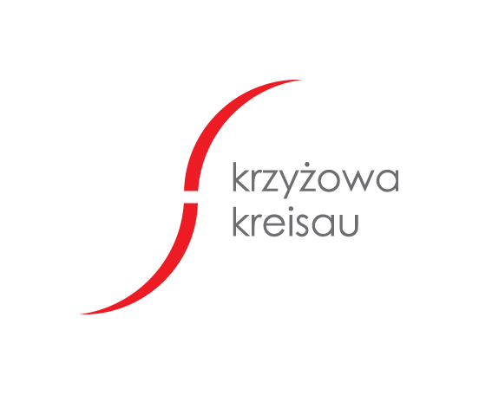

Application form

„Reconciliation and remembrance”
Seminar for Western Balkan, German and Polish students and volunteers
9-13 July 2018

First name
Last name
Adress
E-mail
Phone |  | Age
I am a student | YES |  |  | NO
Name of university, faculty, year of study
Tell us something about yourself
Why would you like to take part in the seminar?

…............................................................... …...............................................
(date) (signature)
- Participation in the seminar is free of charge.  - We provide accommodation and meals.  - Meeting Language: English  - Transportation costs are refundable up to PLN 200 for participants from Poland and up to PLN 400 for participants from Germany.  - Number of participants is limited. Participation only for registered participants after receiving of confirmation. | The form should be sent no later than 29.06.2018  fax: +48 74 85 00 305  phone: +48 74 85 00 301  phone: +48 600 717 960  e-mail: dominik.calka@krzyzowa.org.pl

